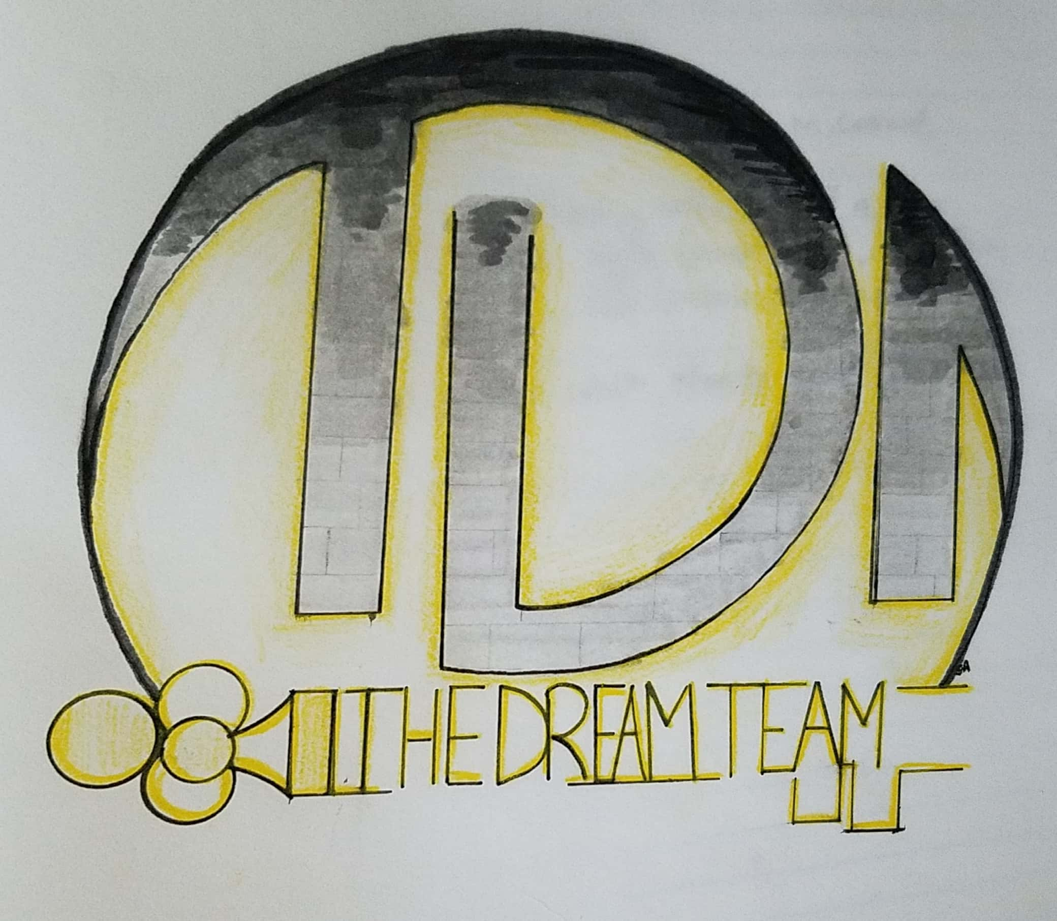
Dream Team

Chasing the End
Request for Proposal
Version 1.0
Document History
Version | When | Who | What
1.0 | 9/15/2018 | Brad Whitesell | Initial Drafting

Table of Contents
- Problem description
- Project Objectives
- Current System(s) – if any or similar systems
- Intended users and their interaction with the system
- Known interactions with other systems inside/outside the client organization
- Known constraints to development
- Project Schedule
- Glossary of terms

- Opportunity Description

The objective for this project is to deliver a single player, top down adventure/puzzle game, titled “Chasing the End.” Modern games often present challenges through difficult and complex mechanics that create a stressful and demanding atmosphere for the player. This project should provide users with a laid-back, retro feeling through a traditional dungeon-crawler like experience. Simple and easy to understand levels and objectives developed in a traditional style should leave users with a nostalgic and accomplished feeling. The mechanics for completing “Chasing the End” should be easily understood, and simple for the casual player to use.

- Project Objectives

The primary objective is to deliver a single player, top down adventure/puzzle game. The atmosphere created by the game should be laid-back, easy to understand and complete, and provide experience game players a sense of nostalgia through a traditional style. The project should include the following features:
- Simple “maze-like” levels
  - Easy to understand obstacles
  - Obvious “exit door”objective for reaching the next level
  - Collectable items needed for proceeding to the next level
- Controllable character
  - Top-down perspective
  - Simple multi-directional movement
  - Ability to collect level unlocking items
  - Capabilities for interacting with exit doors
- HUD/UI
  - Main menu
  - Pause menu
  - Capabilities to save/load the game
  - Inventory indicators
  - Objective prompts
- Enemy AI
  - Simple player tracking enemies that can impede the player
- Cheats to help the player get through the game when they feel faced with a difficult level
- Background music and sound effects for item and enemy interaction

- Current system(s) – if any / similar systems

The following are examples of games with similar mechanics, atmosphere, or genre.

The Binding of Isaac (2011)
The Binding of Isaac is a single player, roguelike game designed by Edmund McMillen and initially released in 2011. Players control a character in a top down fashion through procedurally generated levels and defeat enemy monsters in a real-time fashion with collectable items and power-ups. The player must complete objectives such as defeating boss monsters before the door to the next stage is unlocked and they can proceed.
This title embraces the single player, top down style with simple multi-directional movement that we are looking for in Chasing the End. The focus of Chasing the End; however, should be less on defeating monsters, and more of a focus in exploring the level and finding the collectable item for advancing to the next stage. The Binding of Isaac creates a high-energy and stressful environment that should be avoided by taking the attention away from defeating enemies and avoiding permadeath by placing it on advancing to the next level and forgiving the player for their mistakes.

The Legend of Zelda (1986)
The Legend of Zelda is an action-adventure game developed by Nintendo and initially released in 1986. In the game, players control a character named Link through a top-down perspective and are encouraged to collect fragments of an item called the Triforce of Wisdom to rescue the Princess Zelda. Users must roam a maze-like layout of rooms and are encouraged to fight and defeat all enemies before advancing to the next set of rooms or passages.
The Legend of Zelda helps give a perspective of the nostalgic style and game play that should be achieved through Chasing the End. The title features single player, top down adventure game play. With a primary objective of collecting items to progress. Chasing the End would benefit; however, by not forcing combat, and forgiving players for mistakes. The objective of Chasing the End is to create a laid-back and nostalgic atmosphere, not to create a challenging puzzle/adventure game like The Legend of Zelda.

- Intended users and their basic interaction with the system

The objective of the project is to capture users looking for a casual and laid-back gaming experience. The game should benefit through appealing to older audiences through its traditional style and gameplay.

Users
- Beginning to experienced game players looking for a single player experience
Uses
- Enjoyable and laid-back gaming experience
- Nostalgic gaming experience
- Single player adventure/puzzle experience

- Known interactions with other systems within or outside of the client organization.

Steam (software)
Steam is a digital distribution platform for video games developed by the Valve Corporation. The game should be able to interface with the Steamworks API so that users can install and update their game through the Steam platform.

Operating System
The game should run on modern consumer operating systems, specifically all Windows 10 variants.

- Known constraints to development

The following are known constraints of development.
- Time for completing development. The project must be completed within the University of Idaho 2018 Fall semester.
- Must interface with the systems described in section 5.0.
- The Unity Framework must be used for development.
  - Unity is a cross-platform game engine developed by Unity Technologies and was initially released in 2005.

- Project Schedule

Date | Description
9/18/2018 | Software analysis deadline.
9/20/2018 | Software analysis demo.
9/27/2018 | Code repository chosen and submitted.
10/4/2018 | Initial project draft should compile and run.
10/18/2018 | Project needs two compile paths that run for production and development testing.
11/1/2018 | Code should represent the core of the game with potentially some missing features. Project should run.
11/26/2018 | Final product due.
12/6/2018 | Final presentation.

8.0 Glossary of terms

Top-down – refers to a camera angle that shows the player and the area around them from above.

Adventure/Puzzle game – a video game in which the player assumes the role of a character that progresses through exploration and puzzle solving.

Retro – a style that is a derivative or imitation of aspects of past video games.

Dungeon-crawler – a type of game where players navigate a labyrinthine environment or “dungeon”.

Roguelike – a subgenre of role-playing video games characterized by a dungeon crawl through procedurally generated levels, turn-based gameplay, tile graphics, and permanent death of the playable character.

Steam (software) – a digital distribution platform for video games developed by Valve Corporation that offers digital rights management, matchmaking servers, video streaming, and social networking services. The primary use of Steam involves the installation and automatic updates of games and other software.

Steamworks – the software development kit developed by Valve Corporation for delivering software on Steam.

Unity (software) - a cross-platform game engine developed by Unity Technologies used for creating 3D and 2D games.

